Login in allowed Region with Azure AD Conditional Access  
  
 *Prepared By:  
 --Vatsal Patel*

*--Yash Shah*

*Reviewed By:  
-- Meet Shah*

1. **Login into** [**https://portal.azure.com**](https://portal.azure.com)**.**
2. **Go to Microsoft Entra ID 🡪 Manage 🡪 Security.**

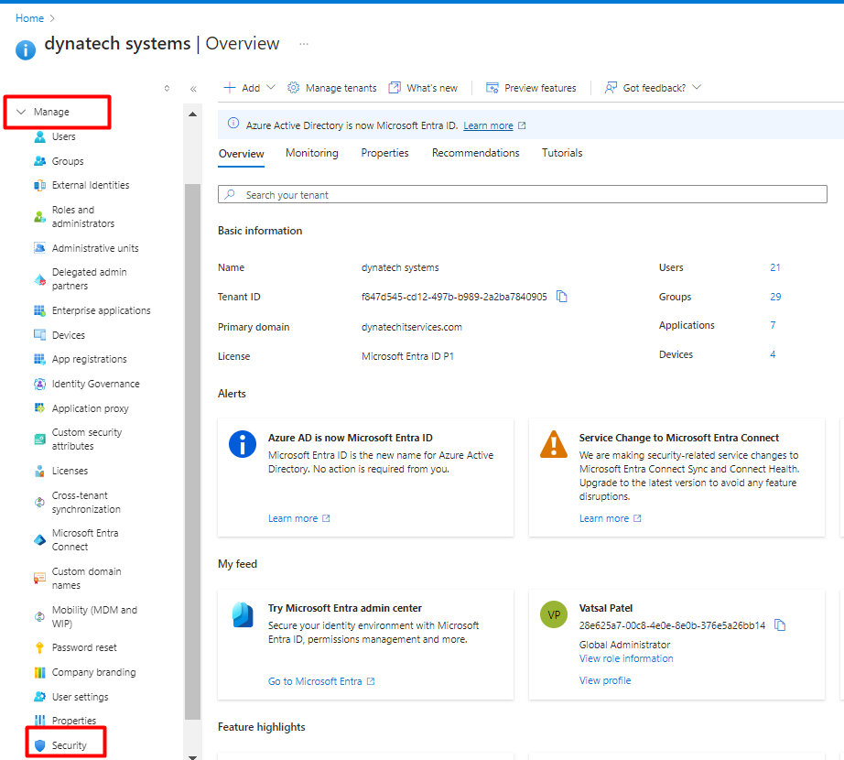

1. **Conditional access 🡪 Named locations 🡪 Countries location.**

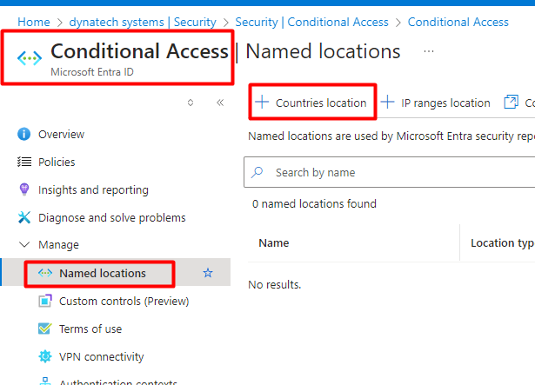

1. **Select country lookup method and countries which you want to allow for login and create.**

1. **Now go to overview 🡪 Create new policy.**

1. **Assignments 🡪 Users 🡪 Select Parameters for include and exclude users as per below screenshots.**

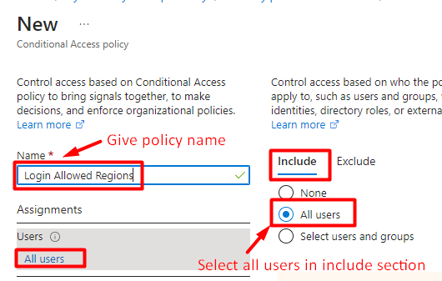

Include Users

**Note: Must add some admin users and users from admin team in exclude.**

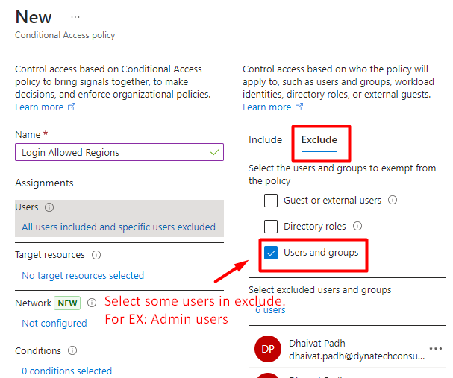

Exclude users

1. **Target resources 🡪 All cloud apps**

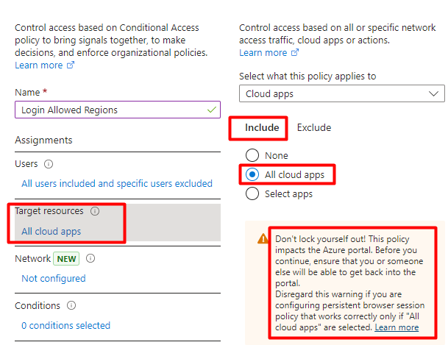

1. **Network 🡪 Any network or location.**

1. **Grant 🡪 Block Access.**

